cs312: INTRODUCTION

1.1 WHAT IS AN ALGORITHM?

The word algorithm comes from the name of a Persian author, Abu Ja'far Mohammed ibn Musa al Khowarizmi (c. 825 A.D.) who wrote a textbook on mathematics.

An examination of the latest edition of Webster's dictionary defines its meaning as "any special method of solving a certain kind of problem."

But this word has taken on a special significance in computer science, where algorithm has come to refer to a precise method useable by a computer for the solution of a problem. This is what makes the notion of an algorithm different from words such as process, technique or method.

Typical algorithms we will include in this class relate to sorting and searching.

To sort means to arrange or classify according to certain set of rules. Example: "sort your homework grades in ascending order".

To search means to seek, to look over carefully in order to find something, to explore, to examine, to probe.

Definition:
An Algorithm is a finite set of instructions which, if followed, accomplish a particular task. Every algorithm MUST satisfy the following criteria:

(1) input: there are one (zero) or more quantities which are externally supplied
(2) output: at least one quantity is produced
(3) definiteness: each instruction must be clear and unambiguous
(4) finiteness: for all cases an algorithm MUST terminate after a finite number of steps.
(5) effectiveness: each instruction must be feasible, that is, it must be sufficiently basic that it can be carried out using only paper and pen.

In formal Computer Science one distinguishes between an algorithm and a program. A program does not necessarily terminate, that is, does not necessarily satisfy condition (4).

One important example of such a program for a computer is its operating system which never terminates (except for system crashes) but continues in a wait loop until more jobs are entered.

An algorithm is composed of a finite set of steps, each of which may require one or more operations.

The study of algorithms includes many important and active areas of research. There are perhaps 5 distinct areas of study one can identify:

- Algorithm Design
- Algorithm Analysis
- Algorithm Expression
- Algorithm Validation
- Algorithm (program)Testing

Our emphasis will be on the first two areas of study. For the third area we will limit ourselves to the use of pseudocode.

What separates pseudocode from real code is that in pseudocode we employ whatever expressive method is most clear and concise to specify a given algorithm.

Trying to specify the essence of an algorithm sometimes the clearest method is just plain English.

Lastly, pseudocode is not concerned with issues related to programming languages such as modularity, error handling, data abstraction, issues with syntax, etc.

Analyzing even a simple algorithm can be a challenge. The mathematical tools required may include discrete combinatorics, elementary probability theory, algebraic dexterity, and the ability to identify the most significant terms in a formula.

Because the behavior of an algorithm may be different for each possible input, we need a means for summarizing that behavior in simple, easily understood formulas.

The time taken by a procedure depends on the input. For example, sorting a thousand numbers takes longer than sorting three numbers.

Moreover, a given sorting algorithm can take different amounts of time to sort two input sequences of the same size depending on how nearly sorted they already are.

In general, the time taken by an algorithm grows with the size of the input, so it is traditional to describe the running time of a program as a function of the size of its input.

To do so, we need to define the terms "running time" or “time complexity” and "size of input" or “space complexity” more carefully.

We shall indicate which input size measure is being used with each problem we study.

The running time of an algorithm on a particular input is the number of primitive operations or "steps" executed.

This is called time complexity of the algorithm. In this class we will most concerned about measuring algorithms time complexity or running time (“the time it takes”).

It is convenient to define the notion of step so that it is as machine-independent as possible.

We will adopt the following view:

A constant amount of time is required to execute each line of our pseudocode.

In the analysis of algorithm, we could look at both the best case and the worst case.

We shall usually concentrate on finding only the worst-case running time, that is, the longest running time for any input of size n.

In measuring the time complexity of an algorithm we shall make one more simplifying abstraction known as the rate of growth or order of growth, of the running time that really interests us.

We usually consider one algorithm to be more efficient than another if its worst-case running time has a lower order of growth. (This evaluation may be in error for small inputs, but for large inputs the best algorithm clearly is faster.)

Measuring the run time of an algorithm

Consider the following pseudo-code:

sum ← 0 // that is, put a zero in variable “sum”, zero out location identified by the
//name “sum”. That is, initially variable sum is zero.

for i ← 1 to n //define a “looping” or “repetitive” activity using a “for” loop and
//variable i such that i takes values from 1 until n.

do sum ← sum + i*i //start increasing variable “sum” with the square of
//variable “i”, that is, by “i*i”.
end //finish the program.

It must be clear that the only input required for this code to execute is “n”.

To any input of size “n” this algorithm will run in an associated time T(n). This T(n) is the time complexity of the algorithm or simply the time it takes this algorithm (program) to execute.

Let’s “measure/calculate” T(n):
- sum ← 0
- for i ← 1 to n
- do sum ← sum + i*i
- end

We start by doing step 1: sum ← 0, which the computer does in a constant time “c₁”.

Next we get into the looping activity. To execute statements (2) and (3) the computer takes also a constant time c₂ for (2) and c₃ for (3). However this is done “n” times with a total time given by: n*(c_{2c}+ c₃)

Lastly statement (4) is executed once for a constant time c₄.

Adding all of these terms we get:

T(n) = c₁ + (c₂ + c₃)*n + c₄ = k₁ +k₂*n

The constants k₁ and k₂ vary with the computer but the running time will always be a linear function of “n”

This is the general idea we will be working with… but we need some basic Algebra!
1.2 BASIC ARITHMETIC/ALGEBRAIC FOMULAE-

Sequences and Series - Basic definitions

Consider the set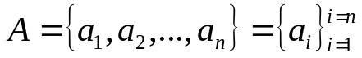. A sequence is typically defined as a function from the set N = {1,2, ..., n} to a set A to generate the elements a_{i}'s of A.

A sequence can be finite (if n is a finite number) or otherwise infinite (an infinite number of elements).

Counting is defined as putting the elements of a set in correspondence with the set of natural numbers {1, 2, ...} so by definition since the set of natural number is infinite, an infinite set can be countable. Non-countable sets are called uncountable.

Assume that i is a natural number.

A sequence is called increasing if a_{i} < a_{i+1} for all i.
It is called non-decreasing if a_{i} ≤ a_{i+1} for all i.
It is called decreasing if a_{i} > a_{i+1} for all i.
It is called non-increasing if a_{i} ≥ a_{i+1} for all i.

Examples:

10, 12, 14, 27, 51. increasing (<).
10, 12, 12, 14, 27, 51. non-decreasing (≤).
27, 12, 6, 5, 2, -1 decreasing (>)
27, 12, 12, 12, 6, 5, 3 non-increasing (≥)

Example:
the sequence 100 is by default increasing, non-increasing, decreasing, non-increasing and this is a totally uninteresting case.

Example:
the sequence given by a_{i} = 1/i for all i ≥ 1, is decreasing.

Assume that a, x, b are all real numbers. A number a is said to be an upper bound for a set X if x ≤ a for all x ∈ X. It is said a lower bound if x ≥ a for all x ∈ X.

A number a is said to be the least upper bound (lub) or supremum of X if a is a upper bound for X and it is the smallest upper bound, that is, if b is an upper bound then a ≤ b.

A number a is said to be the greatest lower bound (glb) or infimum of X if a is a lower bound for X and it is the largest lower bound, that is, if b is an lower bound then a ≥ b.

Examples:
1 is upper bound for the set X = {1 – 1/x | x > 0}. Notice that X in this case does not contain 1.

9 is the lub for the sequence 2, 4, 7, 8, 9.
2 would be its glb.

Series
A series is a summation of the terms of a sequence. There are finite series and infinite series.

The summation symbol used everywhere is the Greek capital letter s: Σ. Where
Σ a_{i} = a₁ + a₂ + a₃ + … + a_{n}.

The multiplication (product) symbol used is the Greek letter P: Π. Where
Π a_{i} = a₁ * a₂ * a₃ * … * a_{n}.

The most important series to be considered are the arithmetic and the geometric series.

We will prove some of these formulas.

1. Prove the following important Arithmetic Series:
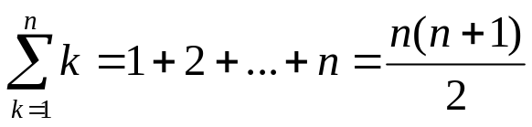
Proof (using only elementary techniques):
We write the finite sum increasingly starting from 1 until n and then we write the sum again decreasingly starting from n until 1, as follows:

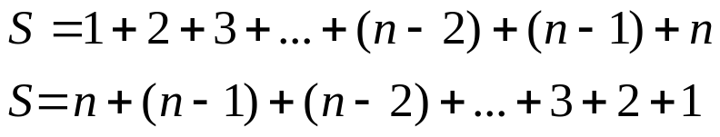

adding these two sum of terms yields on the LHS “2S” (Left Hand Side is 2S) and the RHS (Right Hand Side) yields n times the term (n+1), since we add 1+ n, then 2 + (n–1), next 3 + (n–2), and so on until we add the last two terms n + 1, that is:

2S = n(n+1) ⇒ S = n(n+1)/2, which we write as shown above.

A most important Geometric Series is: 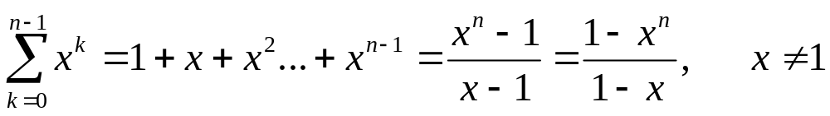

Another important Geometric Series is:

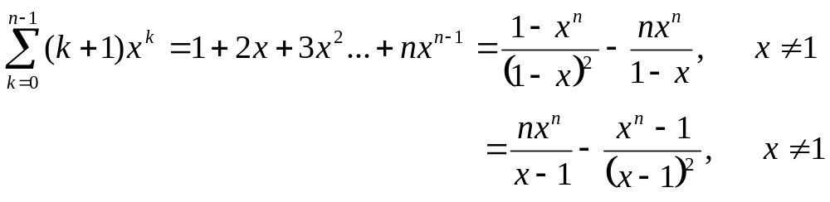
An important Infinite Geometric Series is: 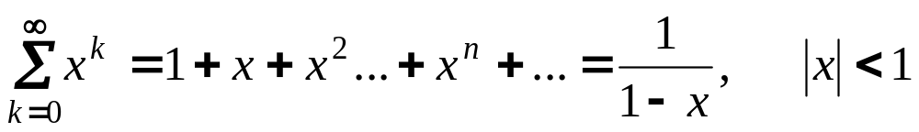

As mentioned earlier, the two basic symbols whose properties you should be aware of are the Summation (Σ) and the Product (Π) symbols:

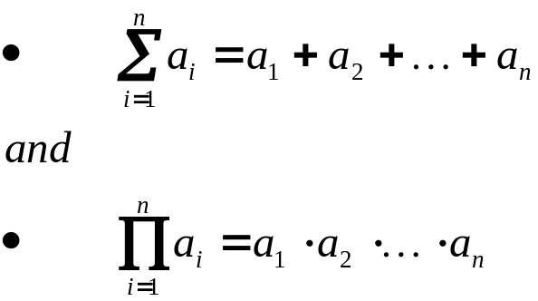

sometimes n, the upper limit of the "sum" (or the "product") symbol, is interpreted to mean "infinite" (∞) and in this case the sum (product) may not exist and we say that the series diverges, otherwise the series converges.

General Formulas we may use in addition to the previous formulas are:

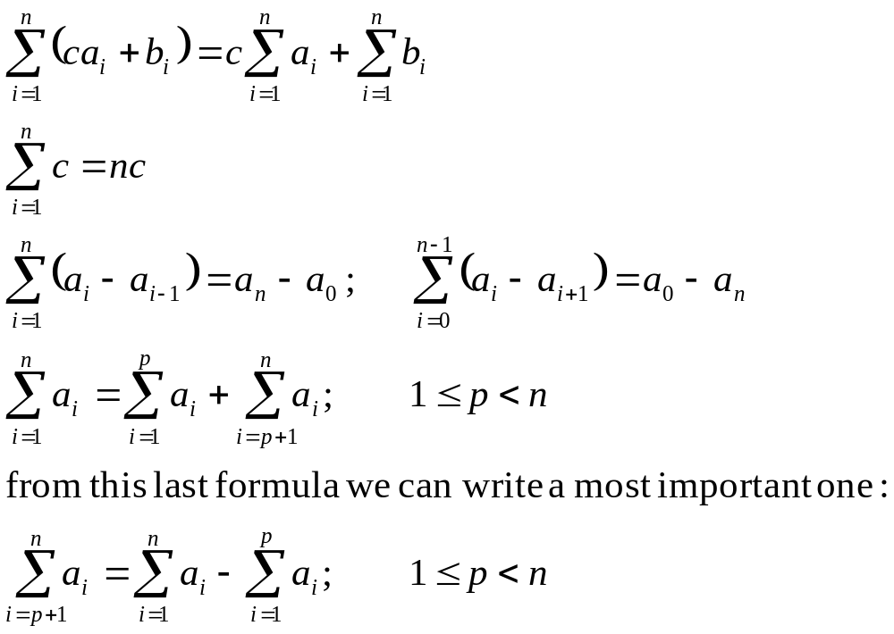

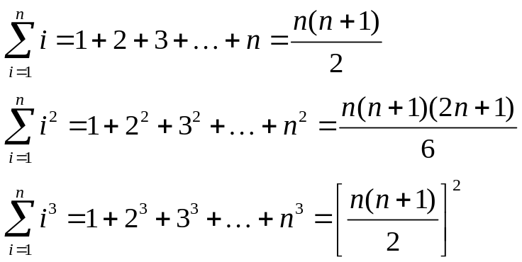

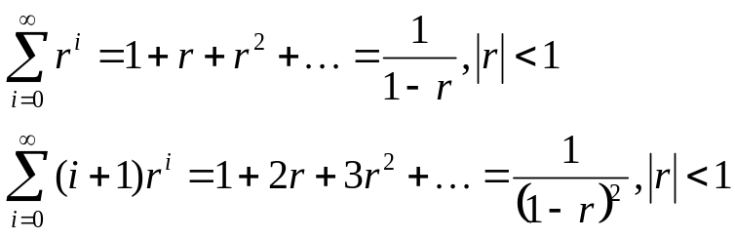

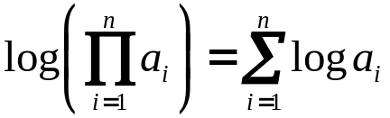

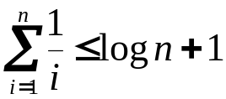 (this formula is known as the harmonic series)
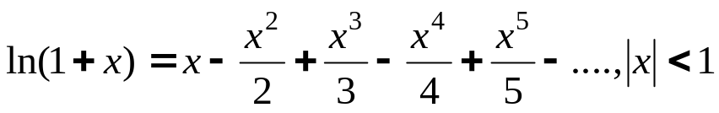
Logarithms

The definition of logarithms (logs) is given by the equation:

a^{x} = N, also written as: x = log_{a} N

which reads x equals logarithm base a of N.

Example:
find x = log₂ 32 ↔ 2^{x} = 32 = 2⁵ → x = 5.

The logs base 10 and base "e" (natural or neperian) are given in most calculators. We use Log or ln or Ln or log_{e} for the natural logarithms.

Logs base 2 are also very popular and they are indicated by using the symbol "lg".

All logarithms are equivalent by means of the following very important transformation formula:

log_{b} N = log_{a} N/log_{a}b.

Example: lg 37 = log37/log2 = 1.56820/0.30103=5.20945

Logs Notation:

lg N = log₂ N
ln N = log_{e} N
log N = log₁₀ N
lg^{k} N = (lg N)^{k}
lglg N = lg(lg N) ( that is lglg N ≠ (lg N)² )

Logs Theorems (most used ones have an *)

N = a^{loga N}
*log_{a} a = 1
*log_{a} 1 = 0
log_{a} (NM) = log_{a} N + log_{a} M
*log_{a} N^{m} = m log_{a} N
log_{a} (M/N) = log_{a} M - log_{a} N
*log_{b} N = log_{a} N/log_{a}b (Ex: lg 37 = log 37/log 2 = ln 37/ln 2)
(log_{b} a) (log_{a} b) = 1
log_{a} (1/M) = - log_{a} M
*N^{logaM} = M^{logaN} (Example: 5^{lg n} = n^{lg 5} = n^{2.32})

The Binomial Theorem

Case 1: n is a natural number.
This is one of the most useful theorems. It will be used many times. Since n is a natural number the expansion consists of n+1 terms given by

where the C coefficients are the binomial coefficients given by the expression:

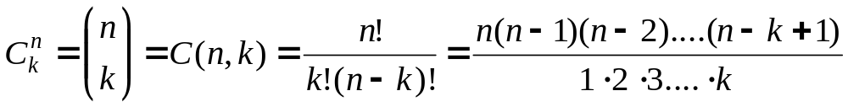
and the signs are positive then + or – and so on alternatively.

Using the formula given above, it is easy to prove the following properties:

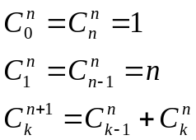 and many others.

The most common type of problems include using the general formula for the (k+1)^{th} term:

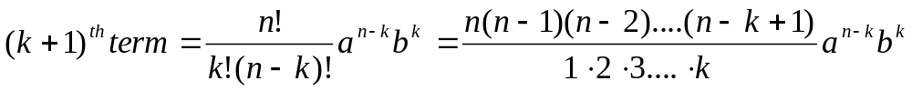

Notice that this is the (k+1)^{th} term and NOT the k^{th} term. The reason for this is that the count of terms begins with the 1st term when k = 0.

A couple of typical examples illustrate the most “difficult cases where these formulas are used.

Example:
Evaluate the 27th term in the expression of (2x² – 3/x²)¹⁰³.

Solution: In this case n = 103, k+1 = 27, a = 2x² and b = -3/x². Then use the formula for the (k+1)^{th} term with k = 26, that is, the 27th term is given by:

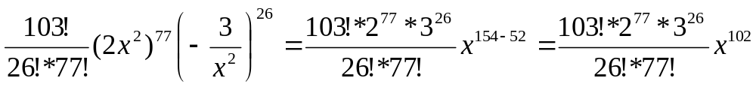

Example:
Find the term without “x” in the expression of (2x² – 3/x²)¹²⁸.

Solution: In this case n = 128, a = 2x², b = 3/x² and the (k+1)^{th} term is given by:
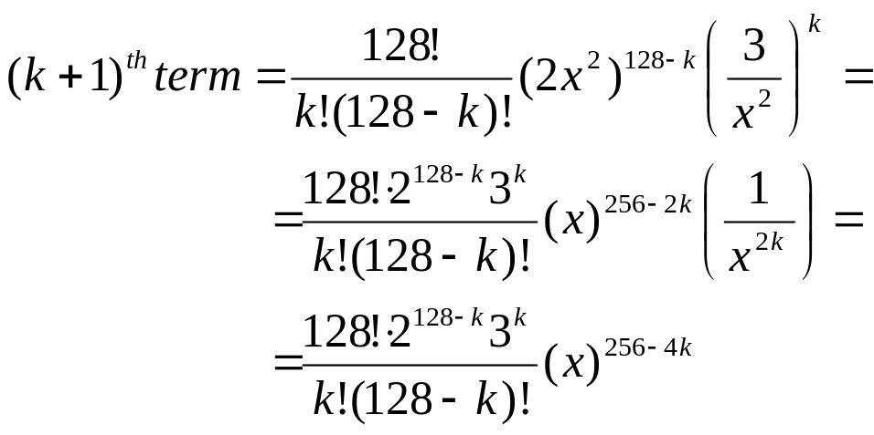

we have that the exponent of x is given by: 2(128-k) – 2(k). To have a term without “x” this exponent must be “0”, that is: 2(128-k) – 2(k) =256 – 4k = 0 ⇒ k = 64.

Therefore the term without “x” is given by: 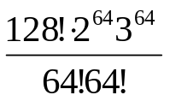

Case 2: n is not a natural number nor zero:

In this case the binomial expansion is infinite, that is:

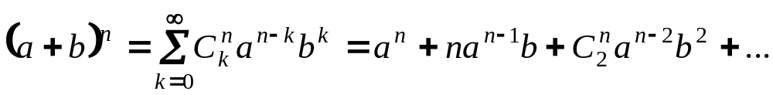

This is the most interesting case and we will see many application. However, first let's consider a most convenient expansion:
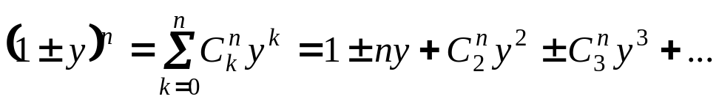

better expressed as follows:

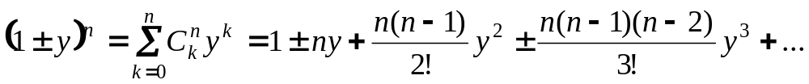

This expansion may be used in most cases provided that in general we factor the binomial as follows:
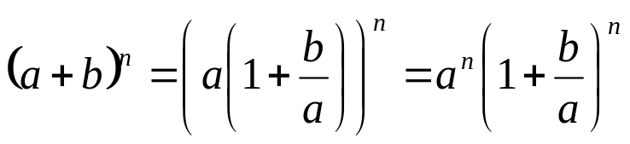

Calling y = b/a we can use the expansion above immediately.

Example using the expansion of (1+y)^{n}:

Expand (1 + x)^{1/2} using the binomial theorem. We know that:

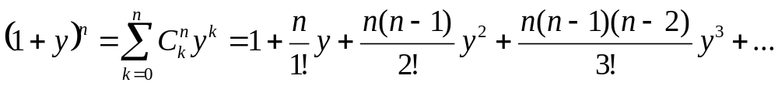
In this case y = x and n = ½.

Answer
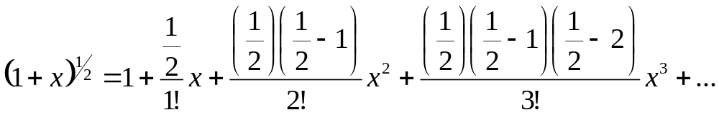
We must be careful not to miss the “general law of formation” for the coefficients:
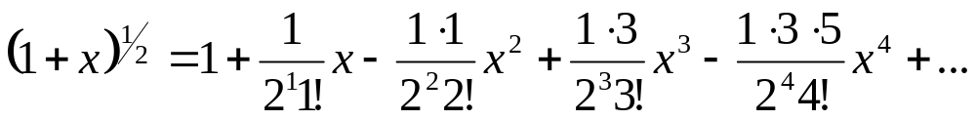

then we find the “general pattern” for the coefficients to find the “expected” answer:

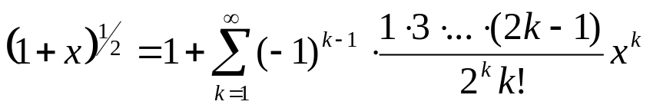.
In this formula the series of products can be expressed using the Π symbol as follows:
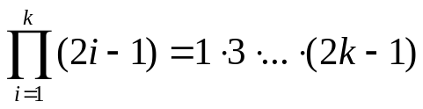
To write in a concise form the expression:
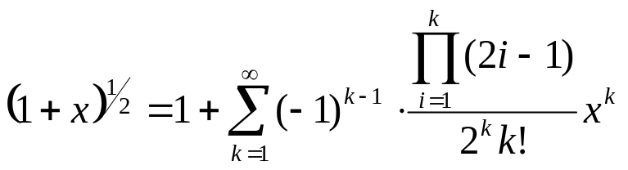

Another example using the expansion of (1+y)^{n}:

Expand (1 + x)⁻³ using the binomial theorem.

Answer

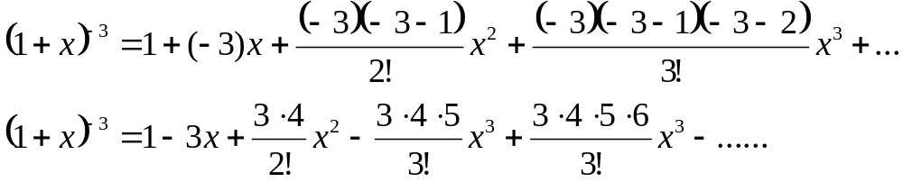
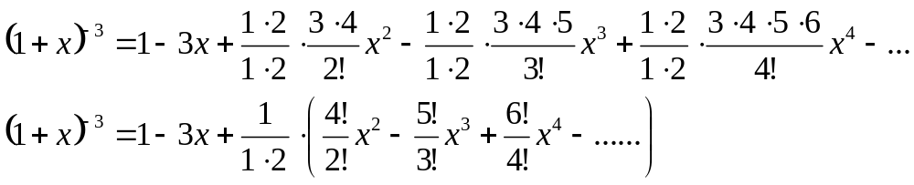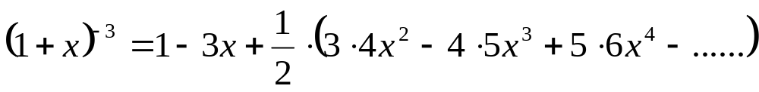
or
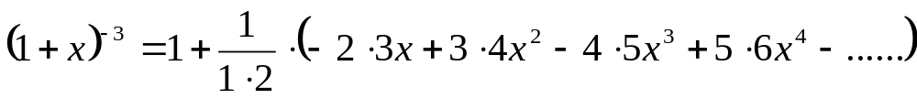

by now the pattern should be evident:

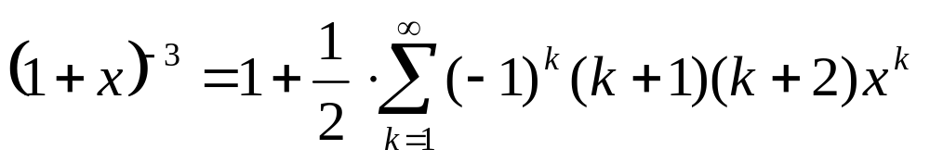

Another more complex example (to be done next class):
Expand using the binomial expansion: 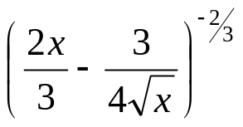use as a pattern the expansion of:
Time Complexity Analysis: Asymptotic notation

The order of growth of the running time of an algorithm gives a simple characterization of the algorithm's efficiency.

Also, the order of growth of the running time of an algorithm allows us to compare the relative performance of alternative algorithms.

Once the input size n becomes large enough, merge sort worst-case running time, beats insertion sort worst-case running time.

Although we can sometimes determine the exact running time of an algorithm, the extra precision is not usually worth the effort of computing it.

For large enough inputs, the multiplicative constants and lower-order terms of an exact running time are dominated by the effects of the input size itself.

When we look at input sizes large enough to make only the order of growth of the running time relevant, we are studying the asymptotic efficiency of algorithms.

That is, we are concerned with how the running time of an algorithm increases with the size of the input in the limit, as the size of the input increases without bound.

Usually, an algorithm that is asymptotically more efficient will be the best choice for all but very small inputs.

The notations we use to describe the asymptotic running time of an algorithm are defined in terms of functions whose domains are the set of natural numbers N = {0, 1, 2,...}.

Such notations are convenient for describing the worst-case running-time function T(n), which is usually defined only on integer input sizes.

It is sometimes convenient, however, to abuse asymptotic notation in a variety of ways.

For example, the notation is easily extended to the domain of real numbers or, alternatively, restricted to a subset of the natural numbers.

It is important, however, to understand the precise meaning of the notation so that when it is abused, it is not misused.

The Big O-notation (Big Oh)

When we have only an asymptotic upper bound, we use the Big Oh, the O-notation.
Definition: For a given function g(n), we denote by O(g(n)), read big Oh of g(n), or O of g(n), or order of g(n), the set of functions:

{f(n) | there exist positive constants c and n₀ such that 0 ≤ f(n) ≤ cg(n) for all n ≥ n₀} = O(g(n)).

We use O-notation to give an upper bound on a function, to within a constant factor.

Figure 3.1 below shows the intuition behind O-notation.

For all values n to the right of n₀, the value of the function f(n) is on or below g(n).

To indicate that a function f(n) is a member of O(g(n)), we write f(n) = O(g(n)).
cg(n)
f(n)
Figure 3.1 f(n) = Ο(g(n))
n
n₀

What may be rather surprising is that any linear function an + b is in O(n²), which is easily verified by taking c = a + |b| and n₀ = 1.

Some readers who have seen O-notation before may find it strange that we should write, for example, n = O(n²).

In this notes, however, when we write

f(n) = O(g(n))

we are merely claiming that, some constant multiple of g(n) is an asymptotic upper bound on f(n), with no claim about how tight an upper bound it is.

Distinguishing asymptotic upper bounds from now become standard in the algorithms literature.

Examples of Big O Calculations

Example 1: Prove that in T(n) = (n+1)² is O(n²).
Proof: We can see that
T(n) = n² + 2n +1 ≤ n² + 2n² + n² = 4n² for n = n₀ ≥ 1.
We have found the constant c = 4 and the value of n₀ which is for n₀ ≥ 1.

Example 2: Prove that 3^{n} is not O(2^{n})

Proof: We need to show that there are constants c and n0 such that 3^{n} ≤ c*2^{n} for n ≥ n₀. That is we need to have a c such that c ≥ (3/2)^{n} for any n ≥ n₀. But (3/2)^{n} grows arbitrarily as n gets large, so no constant c can be larger than the exponential for all n.

Example 3: Let T₁(n) = O(f(n)) and T₂(n) = O(g(n)) be the running times of two sub-programs P₁ and P₂ of a program P. Then the running time of P₁ followed P₂ is T₁(n) + T₂(n) = T(n).
Prove that T(n) = O(max(f(n), g(n))

Proof: We have that:
T₁(n) ≤ c₁*f(n) for n ≥ n₁.
T₂(n) ≤ c₂*g(n) for n ≥ n₂.
Now let n₀ ≥ max(n₁, n₂), then
T(n) = T₁(n) + T₂(n) ≤ c₁*f(n) + c₂*g(n)
yields:
T(n) ≤ (c₁+ c₂)*max(f(n), g(n)) for n ≥ n₀. Put
c = c₁+ c₂, that is T(n) ≤ c*max(f(n), g(n)), n ≥ n₀.
Hence: T(n) = O(max(f(n), g(n))
This is called rule of sums!

Example 4:
Consider the subprograms whose running times are, respectively O(n²), O(n lg n) and O(n³). Then the running time of the first two subprograms running sequentially is O(max(n², n lg n) = O(n²). The running time of all three programs running together is O(max(n², n lg n, n³) = O(n³).

Example 5:
Consider the following times running together:
f(n) = n⁴ if n is even and n² if n is odd
g(n) = n² if n is even and n³ if n is odd
In this case the sum rule applies to f(n) + g(n) where O(max(f(n),g(n)) is n⁴ if n is even and n³ if n is odd.

In a similar way we can prove the rule for products: If T₁(n) is O(f(n)) and T₂(n) is O(G(n)), then T₁(n)*T₂(n) is O(f(n)*g(n)).

Ω-notation (Omega)

Just as O-notation provides an asymptotic upper bound on a function, Ω-notation provides an asymptotic lower bound.

Definition: For a given function g(n), we denote by Ω(g(n)) the set of functions

{f(n) | there exist positive constants c and n₀ such that 0 ≤ cg(n) ≤ f(n) for all n ≥ n₀} = Ω(g(n)).

The intuition behind Ω-notation is shown in Figure 3.2 below. For all values n to the right of n₀, the value of f(n) is on or above g(n).

cg(n)
f(n)
Figure 3.2 f(n) = Ω(g(n))
n
n₀

Since Ω-notation describes a lower bound, when we use it to bound the best running time of the algorithm, by implication we also bound the running time of the algorithm on arbitrary inputs as well.

For example, the best-case running time of insertion sort is Ω(n), which implies that the running time of insertion sort is Ω(n).

The running time of insertion sort therefore falls between Ω(n) and O(n²), since it falls anywhere between a linear function of n and a quadratic function of n.

Moreover, these bounds are asymptotically as tight as possible: for instance, the running time of insertion sort is not Ω(n²), since insertion sort runs in Ω(n) time when the input is already sorted.

It is not contradictory, however, to say that the worst-case running time of insertion sort is Ω(n²),since there exists an input that causes the algorithm to take Ω(n²) time.

When we say that the running time (no modifier) of an algorithm is Ω(g(n)), we mean that no matter what particular input of size n is chosen for each value of n, the running time on that set of inputs is at least a constant times g(n), for sufficiently large n.

Θ - notation (theta)

The Θ-notation asymptotically bounds a function from above and below. For a given function g(n), we denote by Θ(g(n)) (theta of g(n)) the set of functions

{f(n) | there exist positive constants c₁, c₂, and n₀ such that
0 ≤ c₁g(n) ≤ f(n) ≤ c₂g(n) for all n ≥ n₀} = Θ(g(n)).

A function f(n) belongs to the set Θ(g(n)) if there exist positive constants c₁ and c₂ such that it can be "sandwiched" between c₁g(n) and c₂g(n), for sufficiently large n.

Although Θ(g(n)) is a set, we write "f(n) = Θ(g(n))" to indicate that f(n) is a member of Θ(g(n)), or "f(n) ∈ Θ(g(n))."

This abuse of equality to denote set membership may at first appear confusing, but we shall see later in this section that it has advantages.

Figure 3.3 below gives an intuitive picture of functions f(n) and g(n), where f(n) = Θ(g(n)).

For all values of n to the right of n₀, the value of f(n) lies at or above c₁g(n) and at or below c₂g(n). In other words, for all n ≥ n₀, the function f(n) is equal to g(n) to within a constant factor.

We say that g(n) is an asymptotically tight bound for f(n).
c₂g(n)
c₁g(n)
f(n)
Figure 3.3 f(n) = Θ(n)g(n)
n
n₀

The definition of Θ(g(n)) requires that every member of Θ(g(n)) be asymptotically nonnegative, that is, that f(n) be nonnegative whenever n is sufficiently large.

Consequently, the function g(n) itself must be asymptotically nonnegative, or else the set Θ(g(n)) is empty.

We shall therefore assume that every function used within Θ-notation is asymptotically nonnegative.

This assumption holds for the other asymptotic notations defined earlier as well.

Note that f(n) = Θ(g(n)) implies f(n) = O(g(n)), since Θ-notation is a stronger notion than O-notation.

Written set-theoretically, we have Θ(g(n)) 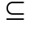 O(g(n)).

Thus, our proof that any quadratic function an² + bn + c, where a > 0, is in Θ(n²) also shows that any quadratic function is in O(n²).

In the literature, O-notation is sometimes used informally to describe asymptotically tight bounds, that is, what we have defined using Θ-notation.

The Θ(n²) bound on the worst-case running time of insertion sort, however, does not imply a Θ(n²) bound on the running time of insertion sort on every input.

In fact when the input is already sorted, insertion sort runs in Θ(n) time.

From the definitions of the asymptotic notations we have seen thus far, it is easy to prove the following important theorem.

Theorem 3.1

For any two functions f(n) and g(n), f(n) = Θ(g(n)) if and only if f(n) = O(g(n)) and f(n) = Ω(g(n)).

As an example of the application of this theorem, our proof that an² + bn + c = Ω(n²) for any constants a, b, and c, where a > 0, immediately implies that

an² + bn + c = Ω(n²) and an² + bn + c = O(n²).

In practice, rather than using Theorem 3.1 to obtain asymptotic upper and lower bounds from asymptotically tight bounds, as we did for this example, we usually use it to prove asymptotically tight bounds from asymptotic upper and lower bounds.

Example
Show that 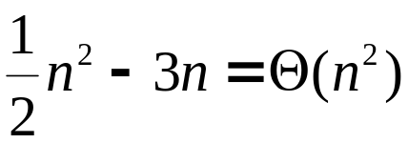

We must determine positive constants c₁, c₂, and no such that
0 < 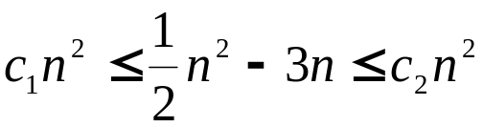
for all n ≥ n₀. Dividing by n² yields
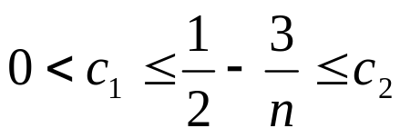
That is:
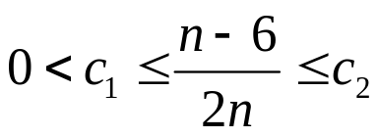
and for these quantities to be positive we must have n > 6. Therefore the left-hand inequality can be made to hold for any value of n ≥ 7, that is:
for n = 7: 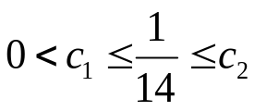; for n = 8: 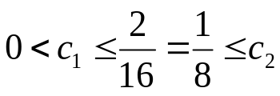; for n = inf: 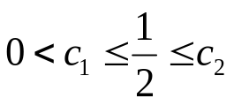

Thus, by choosing c₁ = 1/14, c₂ = 1/2 and n₀ ≥ 7, we can verify that all cases from n = 7 until n = infinite.
.
Certainly, other choices for the constants exist, but the important thing is that some choice exists.

Note that these constants depend on the function ½ n² - 3n; a different function belonging to Θ(n²) would usually require different constants.

